# CSE 318: Max-Cut by GRASP - Report

## 1. High-Level Description of Algorithms

### Randomized Heuristic

The randomized algorithm assigns each vertex randomly to one of two partitions (X or Y) with equal probability. This is repeated multiple times to get an average estimate of the cut weight. It provides fast but unstable results, often far from optimal.

### Greedy Heuristic

The greedy method begins with the edge of highest weight and assigns its endpoints to different partitions. It then assigns each remaining vertex to the partition where it contributes more to the cut, based on total edge weights. It’s deterministic and typically performs better than randomization.

### Semi-Greedy Heuristic

This algorithm combines greedy logic with randomness. At each step, it constructs a Restricted Candidate List (RCL) of good options based on a threshold defined by a tunable α parameter. A random choice from the RCL is used to construct the solution, which improves diversity over the greedy method.

### Local Search

Starting from an existing solution, local search iteratively moves vertices from one partition to the other if doing so increases the total cut weight. It continues until no improving move is found, reaching a local optimum.

### GRASP

GRASP runs multiple iterations of the semi-greedy heuristic followed by local search. It records and returns the best cut found across all iterations. GRASP combines exploration (via randomization) and exploitation (via local optimization) to produce consistently strong solutions.

## 2. Comparison of Algorithm Performance

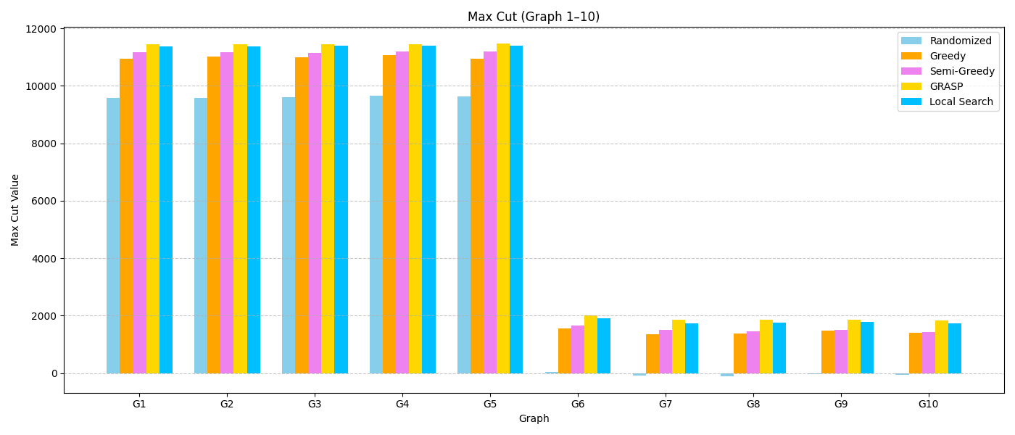From the results obtained across all 54 benchmark graphs, the following trends were observed:  
  
- GRASP consistently outperforms all other algorithms in terms of cut weight. This is expected, as it combines both randomness and local optimization across many iterations.  
- Semi-Greedy performs significantly better than Greedy and Randomized, thanks to its balance between quality and diversity during construction.  
- Greedy generally produces reasonable results, but lacks the ability to escape poor early decisions.  
- Randomized is the weakest performer overall, as it lacks any optimization or selection logic.  
- Local Search, when run independently, often improves solutions generated by Semi-Greedy or Greedy, but still falls short of GRASP’s best values.  
  
The gap between the Randomized and GRASP results is especially visible in the first 10 graphs, where GRASP nearly reaches or exceeds the known best cut in many cases.